DATA608 Knowledge and Visual Analytics (001)

Daniel Craig

9/23/23

# Executive Summary

## Topic: Federal Reserve & Maintaining Economic Stability

#### Target Questions:

1. Has the Federal Reserve been able to fulfill the mandate from Congress which is to control inflation and maintain low unemployment?

**Table of Contents**

Executive Summary 1

Topic: Federal Reserve & Maintaining Economic Stability 1

Target Questions: 1

Context 2

Unemployment Rate: 2

Federal Funds Rate: 2

Consumer Price Index: 3

Overlay: 3

Conclusion\Analysis 4

References & Code Appendix: 5

#### Context

The increase in economic volatility due to COVID and the signs of a looming recession have brought the Federal Reserve under higher scrutiny. From having record low interest rates for an unprecedented amount of time to sharp hikes for an indefinite amount of time, are the Fed’s actions truly managing inflation and unemployment?

Current Consumer Price Index, Federal Funds Rate, and Unemployment Rates for the past 25 years are below. This data was collected using *St. Louis Fed Web Services: FRED® API.*

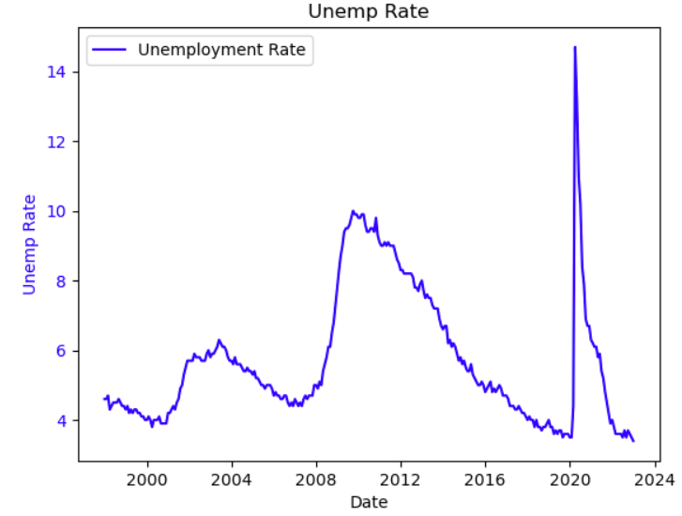

#### Unemployment Rate:

1. Aside from the 2008 Financial Crisis and COVID, unemployment rate has hovered between 6% and 3&

2. Surprisingly, unemployment recovered very quickly after COVID as compared to 2008’s slower progress over 6 to 8 years

#### Federal Funds Rate:

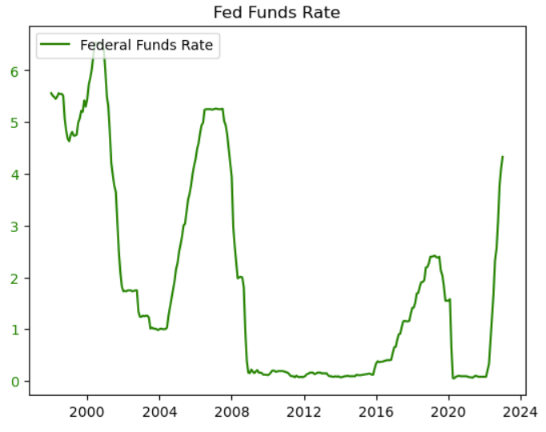1. Comparing the graphs shows a relatively inverse relationship between unemployment rate and the Fed’s main tool for impacting economic stability. Jerome Powell has commented several times on the lagged impact of raising interest rates to be long term, as far as 12 months or more outlier

2. The most notable feature of the plot is astoundingly low, near zero rate from 2008 to 2016

#### Consumer Price Index:

1. A steady increase in consumer prices over the years defines the CPI, with only one notable increase around 2022, aligning with COVID’s pandemic, amounting to an increase

2. A small drop in 2008 was seen, but a titanic increase from 260 to 300 occurred in 2020.

3. Between 2000 and 2020, a steady increase of about 50 points occurred. The average increase being about 2.5 points/year

4. 2021 to 2024 shows an increase of ~45 points, or 15 points/year

4. It is commonly noted that the CPI is inversely related to the unemployment rate with the underlying logic being the more workers employed by companies, the higher prices are to justify companies spending more money on workers (Fernando 2023)

#### Overlay:

1. CPI has been scaled by a factor of 10

2. An expected response to both 2008 and COVID is clear between all 3 metrics

3. Comparing interest rates to unemployment, its clear the Federal Reserve responded to the 2008 crisis by lowering interest rates and began increasing them around 2022, most recently to around 5.0%

##### ***Conclusion\Analysis***

The Federal Reserve has been responding to economic developments primarily by changing the Federal Funds Rate. The typical use of the interest rate is to raise it to slow down borrowing and by effect productivity and expansion, or to raise it to spur investing, hiring, and expansion of businesses.

**Has the Federal Reserve maintained low unemployment?** It’s clear that the Federal Funds Rate is lowered whenever employment begins raising above 5% per evidence from the early 2000s. It’s also clear that the rate is increased once unemployment seems to be dropping below 5%, as evidenced in 2003, 2007, and the slope from 2016 to 2020. In this perspective, the Federal Reserve has at least used the Federal Funds Rate to help manage unemployment rates.

**Has the Federal Reserve managed inflation?** In the context of Federal Funds Rate and Unemployment Rate, it seems that the Price Index steadily rose regardless of the state of the other two. The most notable events were the spike and drop in 2008 and 2009, which seem more likely to be related to the financial crisis rather than interest rates, and COVID. The pandemic showed a slight drop in the CPI but an aggressive climb in the next three years that far out-paced the normal progression. In the past 25 years, the Federal Funds Rate has been above 5% twice, and neither were associated with events as impactful as COVID. The late 90’s could be associated with the “.com” bubble, and heading into 2008 it was clear that the economy was rapidly increasing with the housing bubble. When viewing earlier data, such as the 70s and 80s, there were several times, although for shorter durations, where the Federal Funds Rate went well past 10% (Federal Funds). Despite viewing well past 20 years, one pattern was novel. The near-zero interest rates spanning 2008 – 2016 (nearly a decade), was an unprecedented event. It was clear this started as a response to 2008, but didn’t end until the Federal Reserve saw unemployment fall below 5% which took 8 years. During this time, CPI showed no abnormal behavior, but the speculation remains whether this era of low interest rates was exposed by COVID and caused the drastic increase in CPI. It may also be attributed to the assumed productivity drop experienced by companies with fewer employees or at-home employees, that then caused a necessary price hike. Both of these interpretations would require further investigation. It is unclear whether the Federal Reserve has been successful in managing inflation from looking at these 3 variables.

#### References & Code Appendix:

[DATA608/Major Assignments/Story 2 at main · d-ev-craig/DATA608 (github.com)](https://github.com/d-ev-craig/DATA608/tree/main/Major Assignments/Story 2)

*St. Louis Fed Web Services: FRED® API*. (n.d.). Economic Research Federal Reserve Bank of St. Louis. Retrieved September 23, 2023, from https://fred.stlouisfed.org/docs/api/fred/#API

Fernando, J. (2023, August 11). *Consumer Price Index (CPI) Explained:* Investopedia. Retrieved September 23, 2023, from https://www.investopedia.com/terms/c/consumerpriceindex.asp#toc-what-is-the-consumer-price-index-cpi

*Federal Funds Rate - 62 year historical chart*. (n.d.). MacroTrends. Retrieved September 21, 2023, from https://www.macrotrends.net/2015/fed-funds-rate-historical-chart